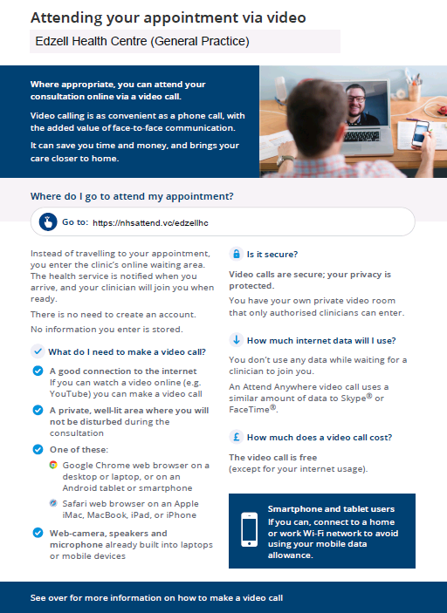

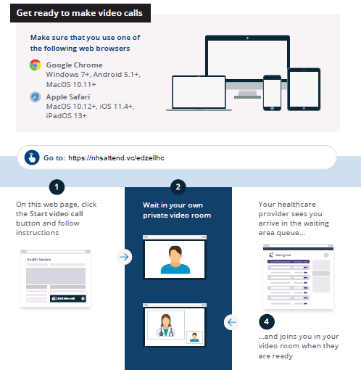

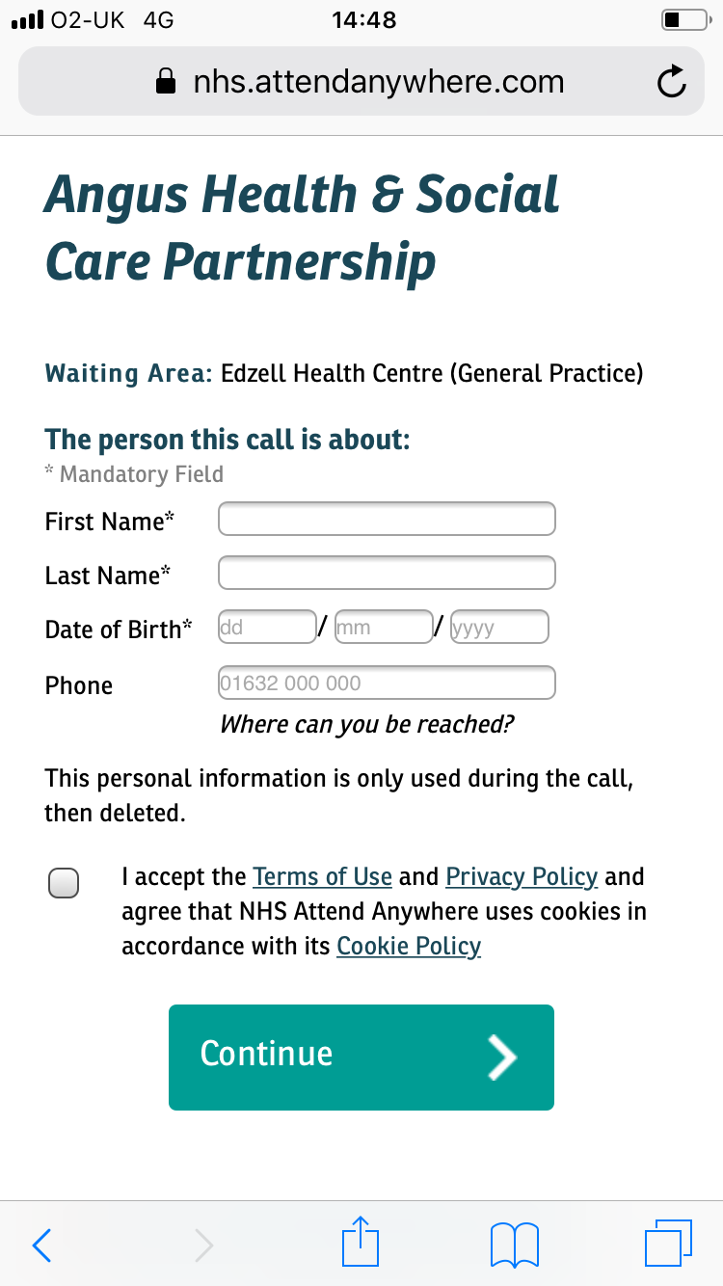
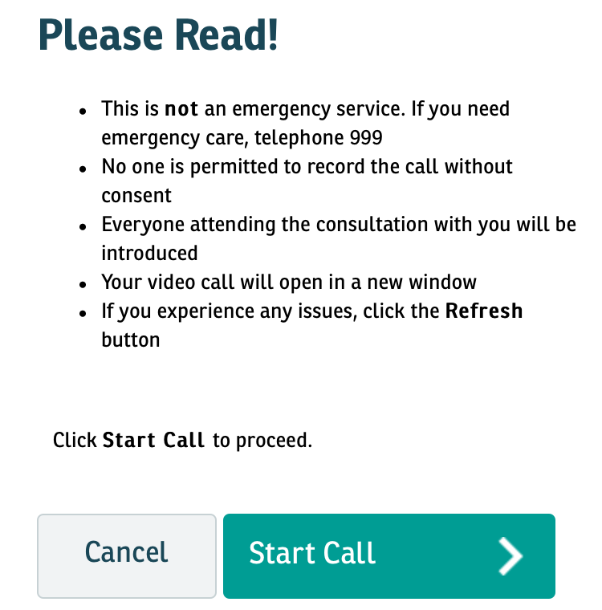
2
3
Enter Your Details

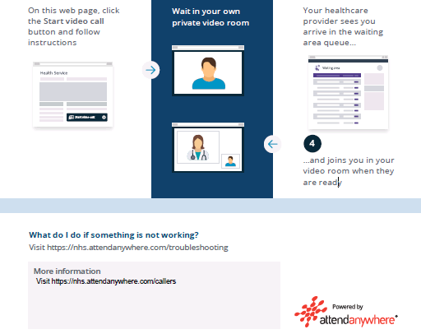
Select:
Allow Access
Allow Access for your Camera and Microphone

You will then enter the Surgery Waiting Room

